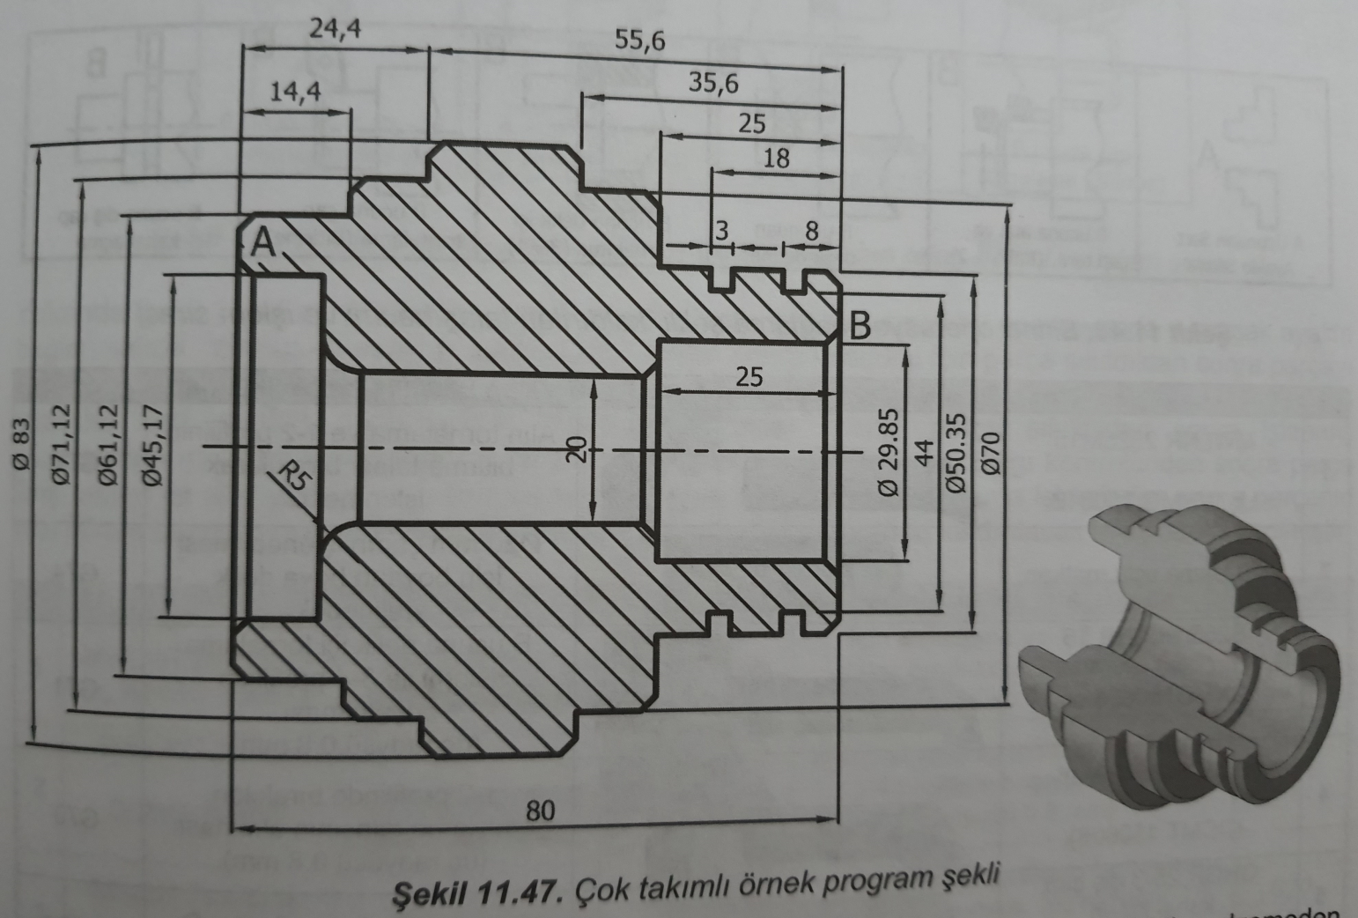

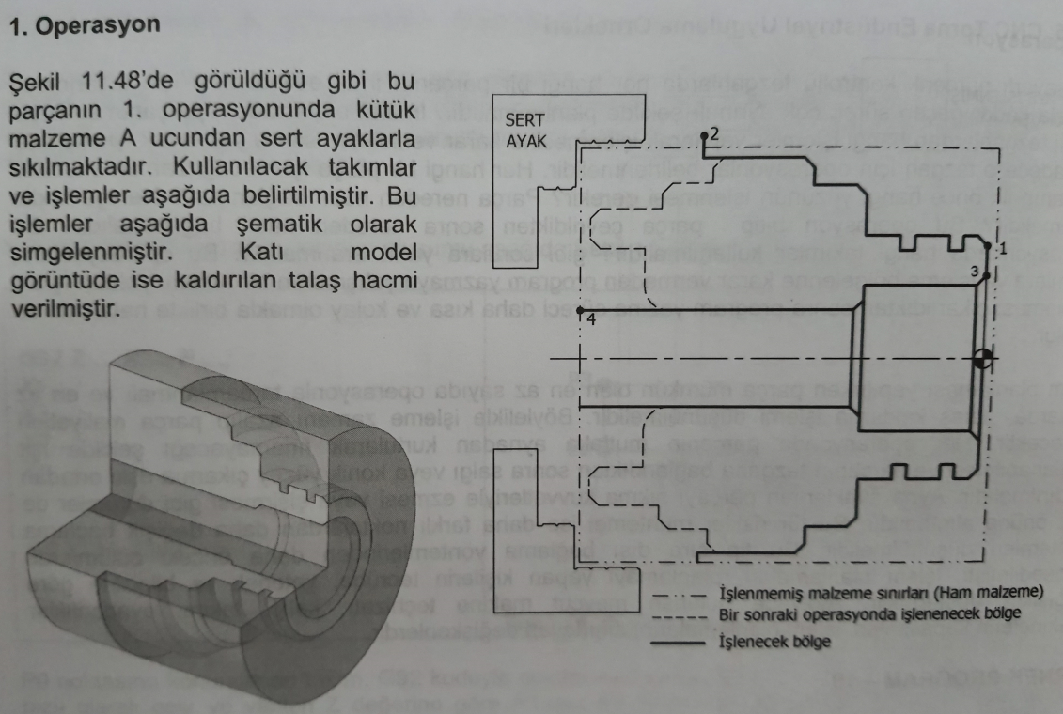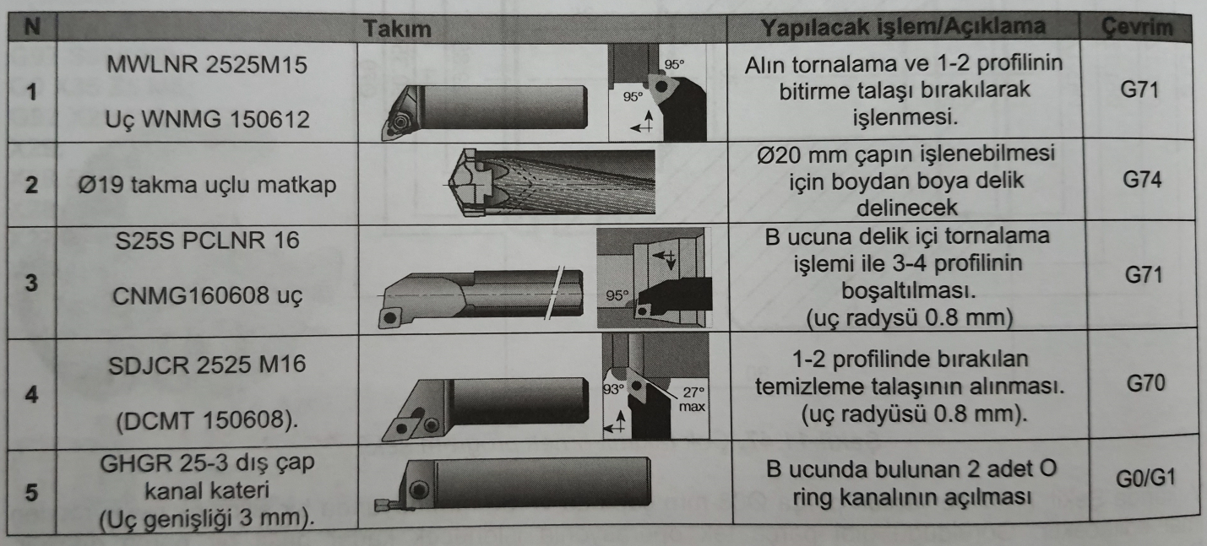

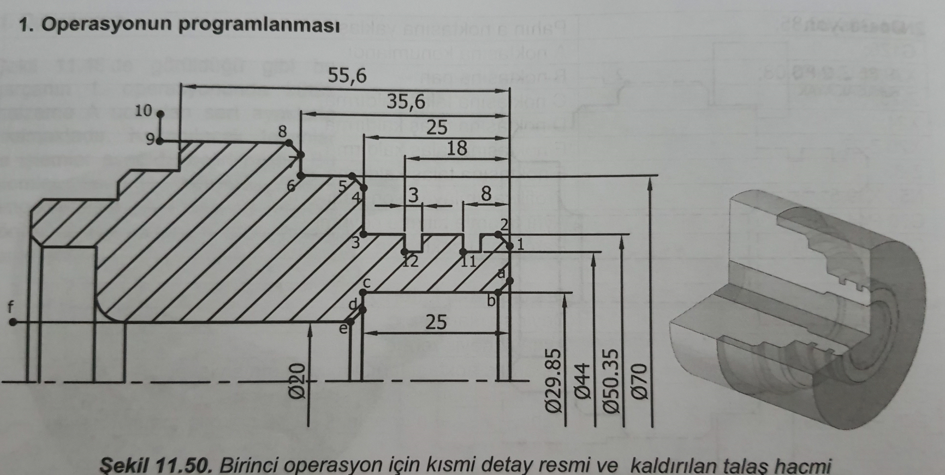

g

|  |  |
| --- | --- |
| O1001 | |
| N5 | T0101; (KABA TALAŞ KALEMİ) |
| N10 | G50 S1500; |
| N15 | G96 S120 M4; |
| N20 | G54 M8; |
| N25 | G0 X90 Z0; |
| N30 | G1 X-0.5 F0.25; |
| N35 | G0 Z2; |
| N40 | X90; |
| N45 | G71 U5 R1; |
| N50 | G71 P55 Q105 U1 W0.5 F0.25; |
| N55 | G0 X46.35; |
| N60 | G1 Z0 F0.15; |
| N65 | X50.35 Z-2; |
| N70 | Z-25; |
| N75 | X66; |
| N80 | X70 Z-27; |
| N85 | Z-35.6; |
| N90 | X79; |
| N95 | X83 Z-37.6; |
| N100 | Z-60; |
| N105 | X90; |
| N110 | G0 X250 Z300 M5; |
| N115 | T0404; (Dış çap finish) |
| N120 | G50 S1500; |
| N125 | G96 S150 M3; |
| N130 | G54 M8; |
| N135 | G0 X90 Z2; |
| N140 | G70 P55 Q105; |
| N145 | G0 x250 z300 M5; |
| N150 | T0202; (Delik açma operasyonu) |
| N155 | G54 M8; |
| N160 | G97 S500 M4; |
| N165 | G0 X0 Z15; |
| N170 | G74 Z-85 Q5 R2 F0.1; |
| N175 | G0 X250 Z300 M5; |
| N180 | T0303; (DELİK İÇİ TALAŞ İŞLEMİ a-f) g noktası eklendi (x19) |
| N185 | G50 s1500; |
| N190 | G96 S125 M3; |
| N195 | G54 M8; |
| N200 | G0 X19 Z2; |
| N205 | G71 U3 R1; |
| N210 | G71 P215 Q250 U1 W0.5 F0.15; |
| N215 | G0 X33.85; |
| N220 | G1 Z0 F0.1; |
| N225 | X29.85 Z-2; |
| N230 | Z-25; |
| N235 | X24; |
| N240 | X20 Z-27; |
| N245 | Z-85 |
| N250 | X19 |
| N255 | G70 P215 Q250; |
| N260 | G0 X250 Z300; |
| N265 | T0505; (KANAL KALEMİ) |
| N270 | G97 S500 M3; |
| N275 | G54 M8; |
| N280 | G0 X52 Z-8; |
| N285 | G1 X44 F0.05; |
| N290 | G0 X52; |
| N295 | G0 Z-18; |
| N300 | G1 X44 F0.05; |
| N305 | G0 X52; |
| N310 | G0 X250 Z300 M5; |
| N315 | M30; |